**Python Tutorial**

Python Programming Language is a high-level and interpreted programming language which was created by Guido Van Rossum in 1989. It was first released in 1991, which results in a great general purpose language capable of creating anything from desktop software to web applications and frameworks.

**Why we Learn Python Programming:**

Python is a high-level dynamic programming language. It is quite easy to learn and provides powerful typing. Python code has a very ‘natural’ style to it, in that it is easy to read and understand.

* Highly readable language
* Clean visual layout
* Less syntactic exceptions
* Superior string manipulation
* Elegant and dynamic typing
* Interpreted nature
* Ideal for scripting and rapid application
* Fit for many platforms

Python can do more it is a very popular language in multiple domains like automation, big data, AI etc.

**Python Installation**:

Go to the the link: <https://www.python.org/downloads/> and install the latest version on your machines.

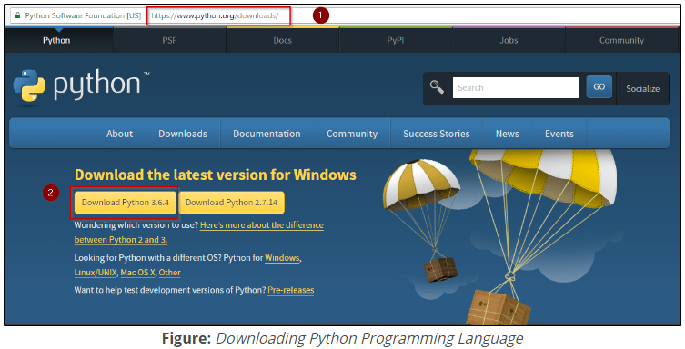

Download and install PyCharm IDE

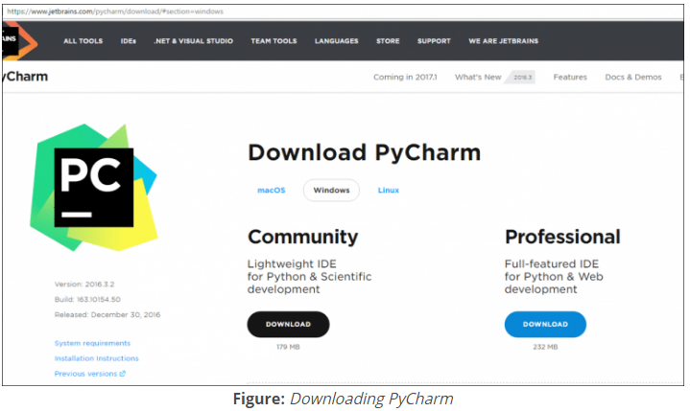

PyCharm is an Integrated Development Environment (IDE) used in computer programming, specifically for the Python programming language. It provides code analysis, a graphical debugger, an integrated unit tester, integration with version control systems (VCSes), and supports web development with Django.

**Python Fundamentals:**

The following are the five fundamentals required to master Python:

1. Datatypes
2. Flow Control
3. Functions
4. File Handling
5. Object & Class

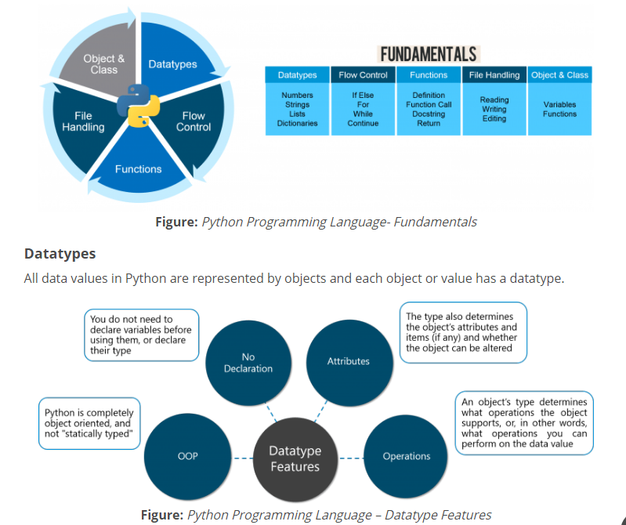

**There are eight native datatypes in Python:**

1. Boolean
2. Numbers
3. Strings
4. Bytes & Byte Arrays
5. Lists
6. Tuples
7. Sets
8. Dictionaries

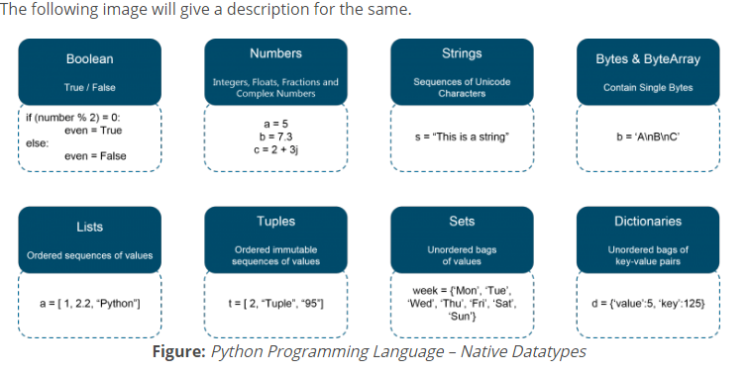

Examples of Data Types:

>>> #Boolean

>>> number=[1,2,3,4,5]

>>> boolean=3 in number

>>> print(boolean)

True

>>> #Strings

>>> str1='Hello world welcome to python tutorial'

>>> str1

'Hello world welcome to python tutorial'

>>> str1[-2]

'a'

>>> str1[0:]

'Hello world welcome to python tutorial'

>>> str1[3:]

'lo world welcome to python tutorial'

>>> str1[:5]

'Hello'

>>> str1[5:2]

''

>>> str1[5:3]

''

>>> str1[-5:]

'orial'

>>> str1[:-5]

'Hello world welcome to python tut'

>>> str1[0:10]

'Hello worl'

#lists : Is a collection which is ordered and changeable. Allows duplicate members.

>>> countries=['India','Australia','Japan','North KOrea']

>>> countries

['India', 'Australia', 'Japan', 'North KOrea']

>>>

>>> len(countries)

4

>>> print(len(countries))

4

>>> countries.append('Brazil')

>>> countries

['India', 'Australia', 'Japan', 'North KOrea', 'Brazil']

>>> countries.extend('Chain')

>>> countries

['India', 'Australia', 'Japan', 'North KOrea', 'Brazil', 'C', 'h', 'a', 'i', 'n']

SyntaxError: unexpected indent

>>> countries

['India', 'Australia', 'Japan', 'North KOrea', 'Brazil', 'C', 'h', 'a', 'i', 'n']

>>> countries.insert(2,'USA')

>>> countries

['India', 'Australia', 'USA', 'Japan', 'North KOrea', 'Brazil', 'C', 'h', 'a', 'i', 'n']

>>>

>>> countries[7]='Kochhi'

>>> countries

['India', 'Australia', 'USA', 'Japan', 'North KOrea', 'Brazil', 'C', 'Kochhi', 'a', 'i', 'n']

>>>

>>> #Tuples:

A Tuple is a collection of Python objects separated by commas. In some ways a tuple is similar to a list in terms of indexing, nested objects and repetition but a tuple is immutable unlike lists which are mutable.

>>> tu=['uma',123,45,0.78,'cricbuzz']

>>> tu

['uma', 123, 45, 0.78, 'cricbuzz']

SyntaxError: invalid syntax

>>> tu

['uma', 123, 45, 0.78, 'cricbuzz']

>>> tu.append('sports')

>>> tu

['uma', 123, 45, 0.78, 'cricbuzz', 'sports']

>>> tu[1]='crl'

>>> tu

['uma', 'crl', 45, 0.78, 'cricbuzz', 'sports']

>>> tu[123]='has'

Traceback (most recent call last):

File "<pyshell#148>", line 1, in <module>

tu[123]='has'

IndexError: list assignment index out of range

#Dictionaries: Dictionary is an unordered collection of **key-value pairs**. Dictionaries are used to handle large amount of data.

Python dictionary is an implementation of a hash table and is a **key-value** store. It is not ordered and it requires that the keys are hashtable. Also, **it is fast for lookups by key.**

**Ex: phonebook, index.**

dict={1:'uma',2:'shri',5:'ram'}

>>> dict

{1: 'uma', 2: 'shri', 5: 'ram'}

>>> del dict {1}

SyntaxError: invalid syntax

>>> del dict[1]

>>> dict

{2: 'shri', 5: 'ram'}

>>>

>>> Govt=['YSRCP','Congress','BJP','Janasena']

>>> govt

Traceback (most recent call last):

File "<pyshell#154>", line 1, in <module>

govt

NameError: name 'govt' is not defined

>>> Govt

['YSRCP', 'Congress', 'BJP', 'Janasena']

>>>

>>> print('the Indian government has',Govt)

the Indian government has ['YSRCP', 'Congress', 'BJP', 'Janasena']

>>> Govt['Congrass']='Prajarajyam'

Traceback (most recent call last):

File "<pyshell#158>", line 1, in <module>

Govt['Congrass']='Prajarajyam'

TypeError: list indices must be integers or slices, not str

>>> Govt['Congress']='Prajarajyam'

Traceback (most recent call last):

File "<pyshell#159>", line 1, in <module>

Govt['Congress']='Prajarajyam'

TypeError: list indices must be integers or slices, not str

>>>

SET:

A Python set is a slightly different concept from a list or a tuple. A set, in Python, is just like the mathematical set. It does not hold duplicate values and is unordered. However, it is not immutable, unlike a tuple.

Sets can user methods like pop(),discard(),clear(),remove(),add()

And Functions like len(),max()..

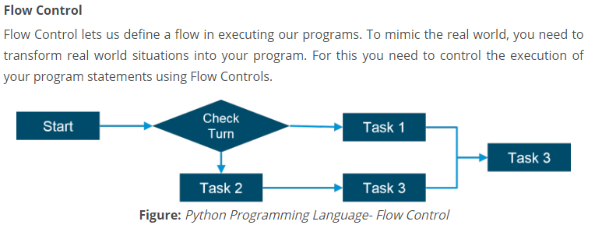

There are six flow controls in python

* If
* For
* While
* Break
* Continue
* Pass

**If Statements:**

**Syn**: if expressions:

elif statements;

if expression:

elif statements;

if expressions:

elif statements;

In python IF Statement is used for decision making it will run the code only the statement is true.

### checking the year is a leap year or not ###

**year=int(input("Enter year to be checked:"))  
if(year%4==0 and year%100!=0 or year%400==0):  
 print("The year is a leap year!")  
else:  
 print("The year isn't a leap year!")**

**table program**

**n=int(input("enter number:"))  
for i in range(1,11):  
 print(n,'X',i, "=", n*i)**

**""" Union of two lists """  
""" l1 = []  
num1 = int(input('Enter size of list 1: '))  
for n in range(num1):  
 numbers1 = int(input('Enter any number:'))  
 l1.append(numbers1)  
  
l2 = []  
num2 = int(input('enter size of list 2: '))  
for n in range(num2):  
 numbers2 = int(input('Enter any number:'))  
 l2.append(numbers2)  
  
union = list(set().union(l1,l2))  
  
print('the union of two lists is :', union) """**

import csv

with open('cr_ins.csv','r') as csv_file: #Opens the file in read mode

csv_reader = csv.reader(csv_file) # Making use of reader method for reading the file

for line in csv_reader: #Iterate through the loop to read line by line

print(line)